**Python Database Application Development**

**Installation of Wxpython**

apt-get install python-wxgtk2.8

wxPython is a cross platform toolkit for creating desktop GUI applications. wxPython consists of the five basic modules.

### wxPython modules

**a Panel, a Dialog, a Frame, or a Scrolled Window**

**logging, application configuration, system settings, display or joystick**

**Drawing onto the widgets**

**Sizer, layout, event, geoemtry classes**

**Button, Toolbar**

### Base Widgets:

### These widgets provide basic functionality for derived widgets

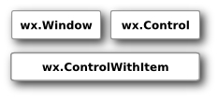

### Top level Widgets

These widgets exist independently of each other.

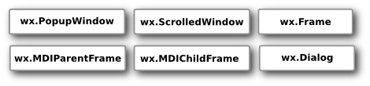

### Containers

Containers contain other widgets.

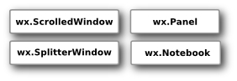

### Dynamic Widgets

These widgets can be edited by users.

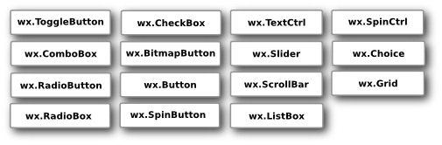

### Static Widgets

These widgets display information. They cannot be edited by user.

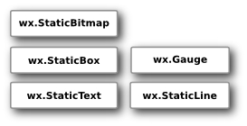

### Other Widgets

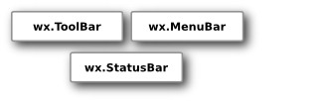

### Inheritance

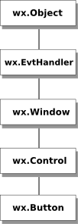

**Application Development:**

**Frame Creation on Python Code**

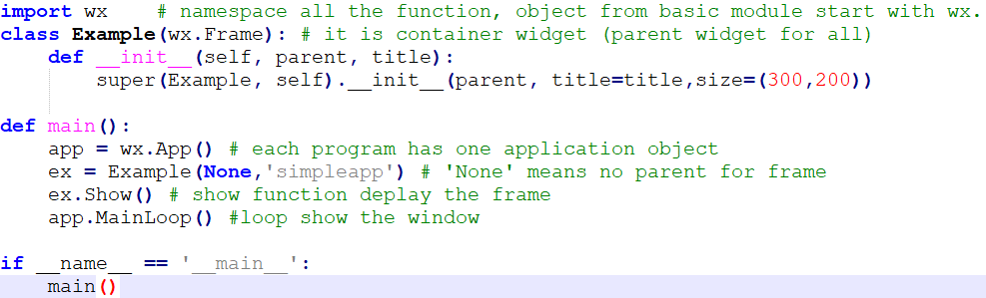

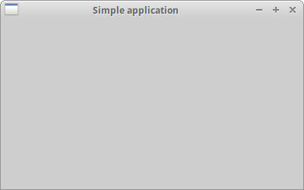

**ADD Menus in the Application:**

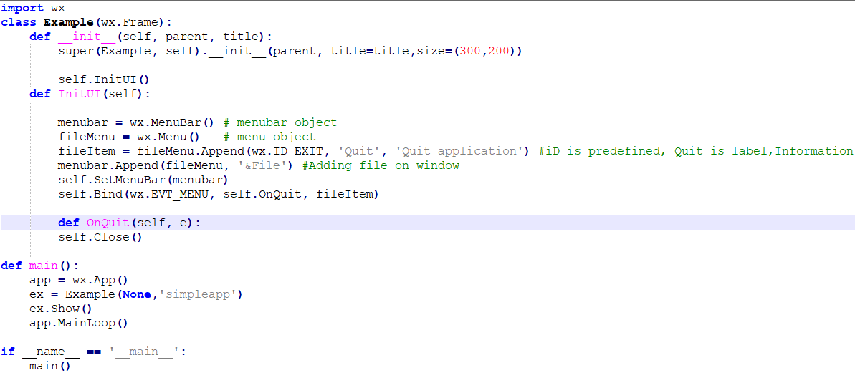

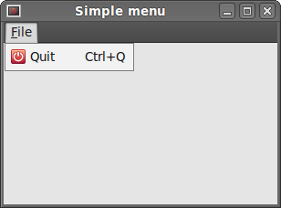

**Add Panel inside the Frame:**

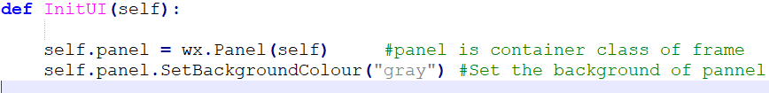

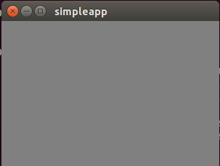

**LAYOUT (Border)**

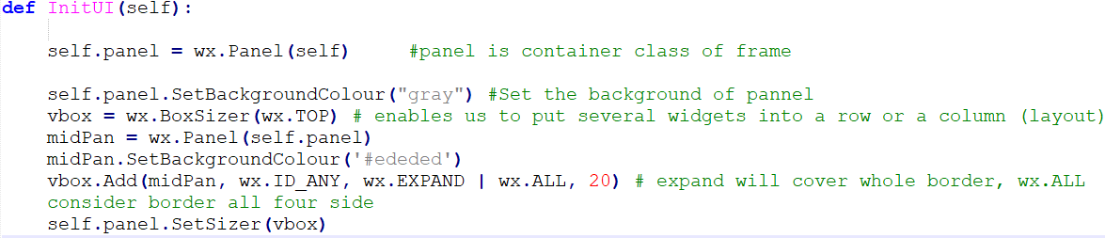

* wx.LEFT
* wx.RIGHT
* wx.BOTTOM
* wx.TOP
* wx.ALL
* wx.ALIGN_LEFT
* wx.ALIGN_RIGHT
* wx.ALIGN_TOP
* wx.ALIGN_BOTTOM
* wx.ALIGN_CENTER_VERTICAL
* wx.ALIGN_CENTER_HORIZONTAL
* wx.ALIGN_CENTER

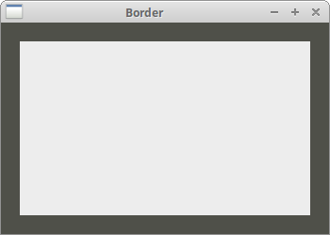

**SET Font/Button/vbox/hbox :**

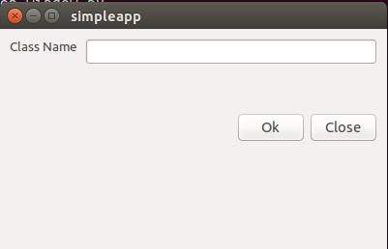

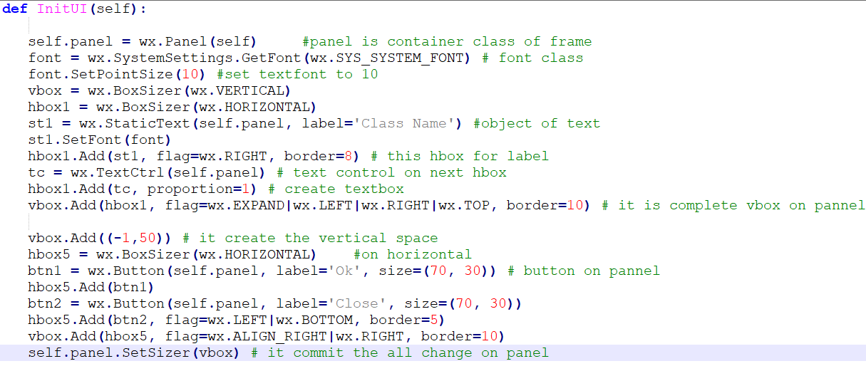

**Layout widgets in two dimensional table:**

wx.GridSizer(int rows=1, int cols=0, int vgap=0, int hgap=0)

In the constructor we specify the number of rows and columns in the table and the vertical and horizontal space between our cells.

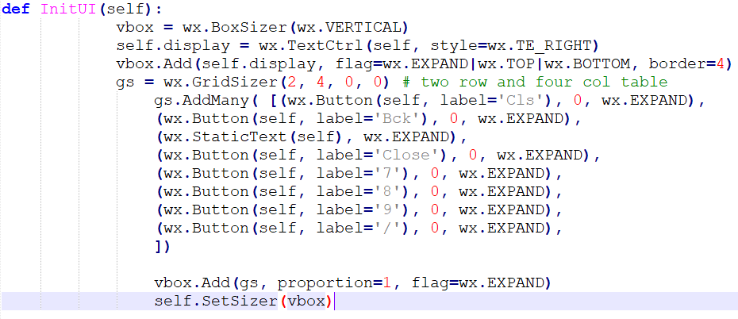

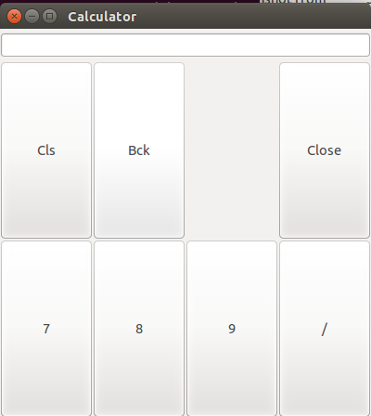

# Events in wxPython:

Events are integral part of every GUI application. All GUI applications are event-driven.

The three steps to work with events in wxPython are:

* Identify the event binder name: wx.EVT_SIZE, wx.EVT_CLOSE etc.
* Create an event handler. This method is called when an event is generated.
* Bind an event to an event handler.

## wxPython wx.EVT_MOVE

## 

## Move event

## wxPython Event Propogation:

1. Basic events do not propagate:
2. Command events do propagate.
3. To continue propagation, we call the Skip() method.

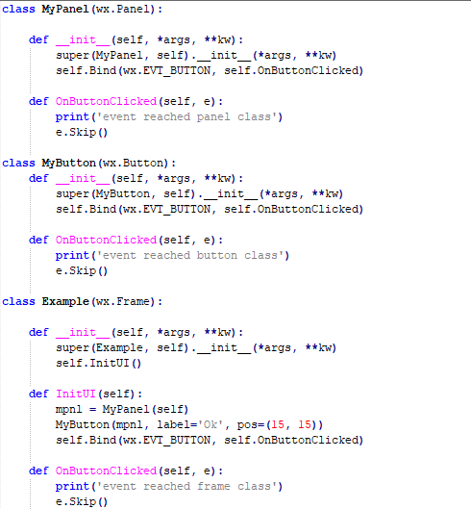

## Message dialogs

## Message dialogs are used to show messages to the user.

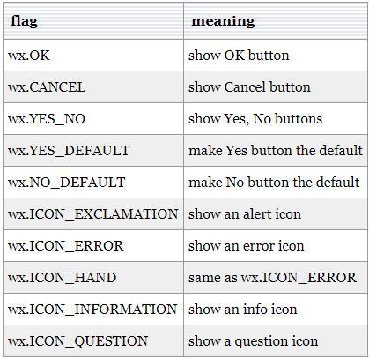

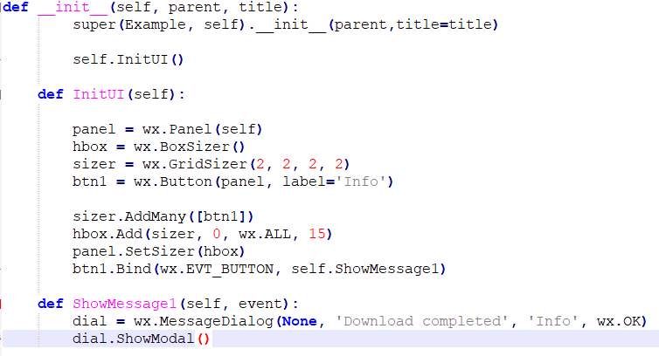

**Widgets:**

**Button:**

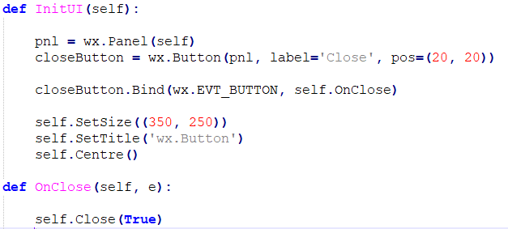

**ToggleButton**

wx.ToggleButton is a button that has two states: pressed and not pressed.

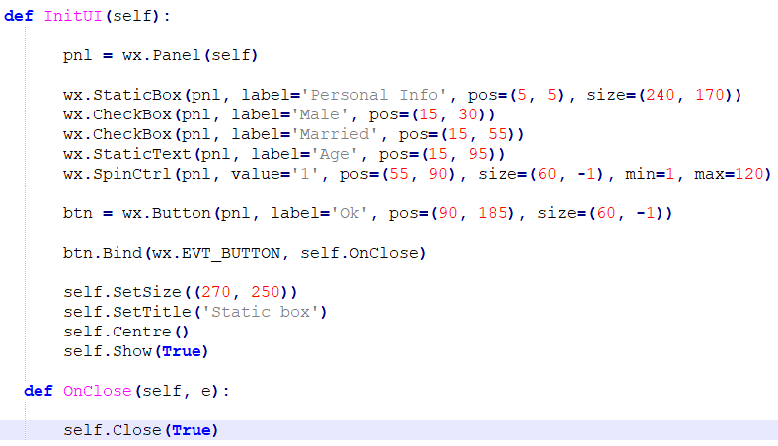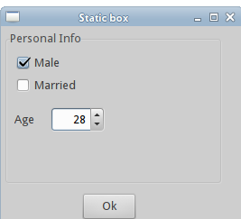

**ComboBox**

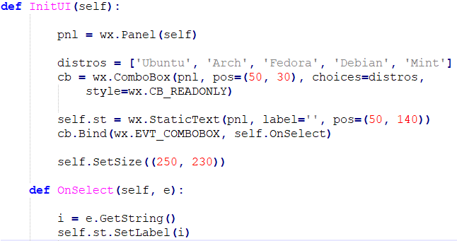

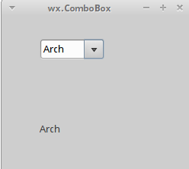

**CheckBox**

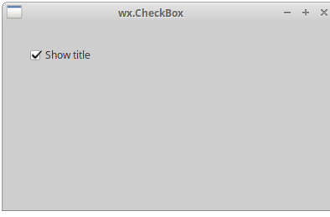

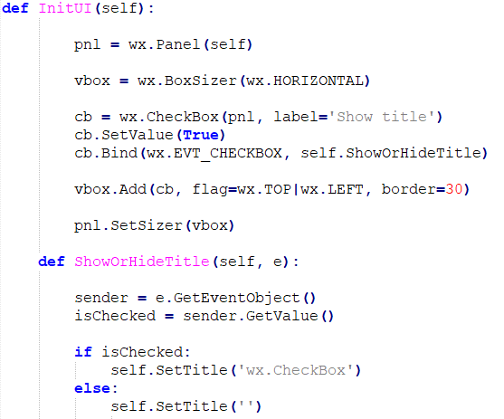

Foe building the python GUI Application this much is more than enough, Even if you want to give more between look to you application take a look below link

<http://zetcode.com/wxpython/>

**Python MySQL**

**Install:** sudo apt-get install python-mysqldb

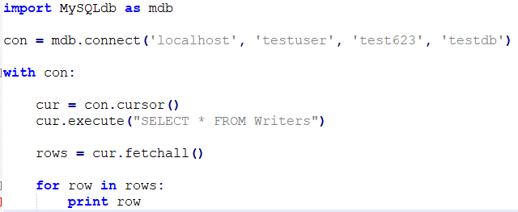

## MySQLdb column headers

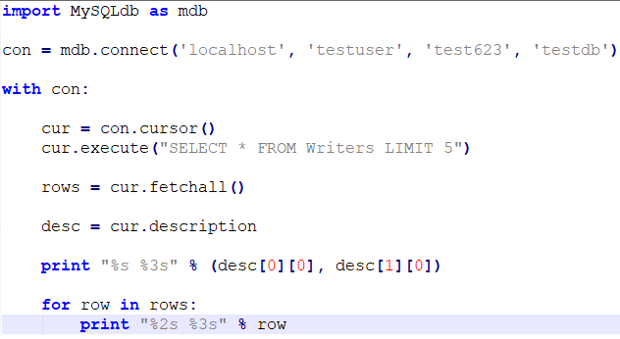

**Update Tuple in Relation**

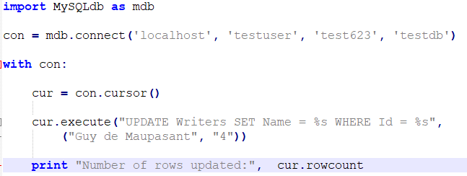

**Insert Image**

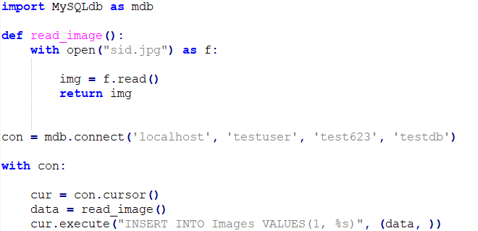

## MySQLdb read image

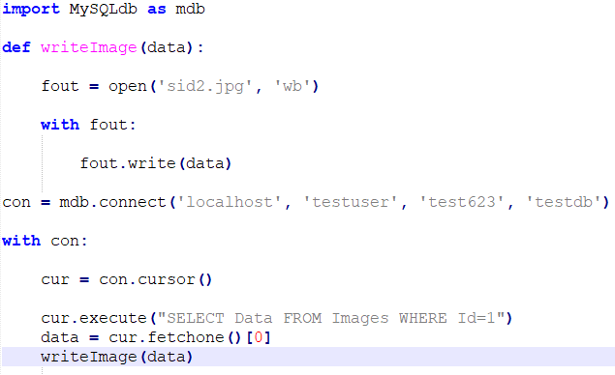

**MySQL Inset update all together**

